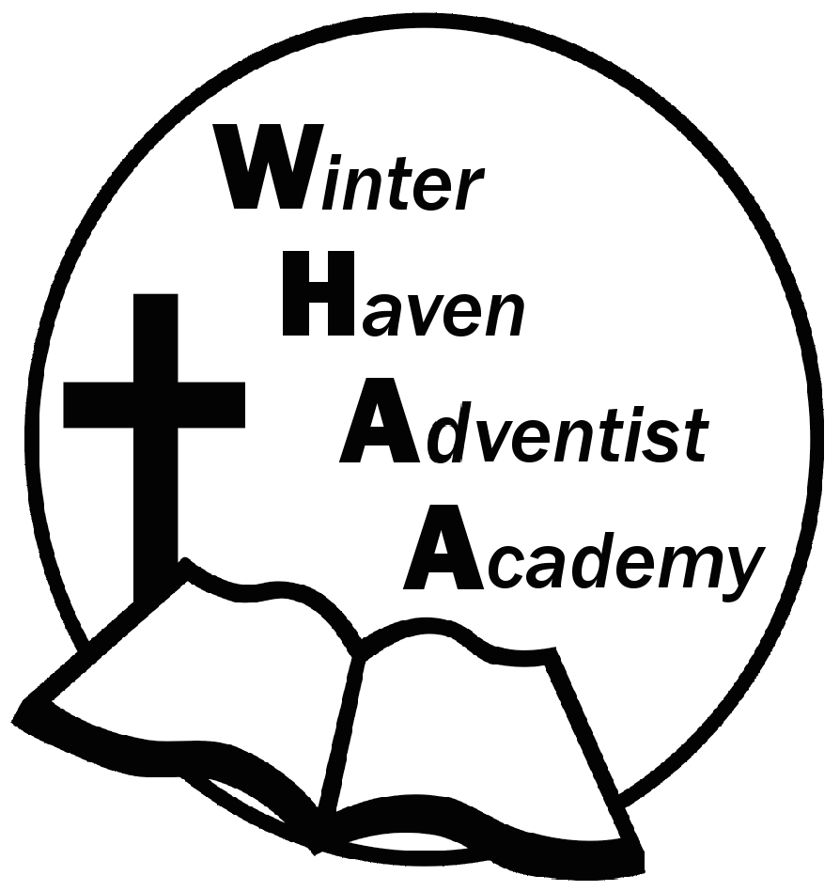
Winter Haven Adventist Academy
Adventist Education

A Journey to Excellence
Week 10 October 16-20, 2023 Newsletter

Dear WHAA Families,
This tenth week of the 2023-2024 school year has been another wonderful week. Our second quarter has just begun. Worships this week were brought to us by Mr. Grimm and focused on the topic of generosity. Thank you for everyone’s participation in setting up parent-teacher conferences.
Below are some important events to remember.
PARENT TEACHER CONFERENCES: WHAA wants to remind parents that October 23-27 will be the week of parent teacher conferences. Report cards will be given out and MAP Testing results discussed. If you have forgotten your day and time email Mr. Grimm and he will respond by email to inform you. We look forward to seeing all the parents. Mr. Grimm’s email: corey.grimm@flcoe.org.
SATURDAY, NOVEMBER 11 FAMILY SABBATH: WHAA wants to remind families that the next school program will be Saturday (Sabbath), November 11. WHAA plans to have a church service, potluck, and an evening vesper. Remember that the students will wear the white school shirt and black pants/skirt. More information about arrival time and the other planned events will come later.
Thank you for your prayers and support. WHAA continues to pray for all the families. Have a blessed and restful weekend!

- Important Dates:
Saturday, November 11 Family Sabbath
Wednesday, November 15 Sea World Orlando $40 per child and adult
Monday-Friday, November 20-24 Fall Break (No School)
Wednesday, December 13 Ice Factory Kissimmee $20 per child and adult (who is ice skating)
Monday-Friday, December 18-January 1 Winter Break (No School)
Tuesday, January 2 Classes Resume for Third Quarter

Winter Haven Adventist Academy (WHAA)
"Wisdom and Harmony, Anchored in Achievement"

The Wisdom of God, the Harmony of the Holy Spirit, Anchored
in Jesus and Advancing the Achievement Together.

