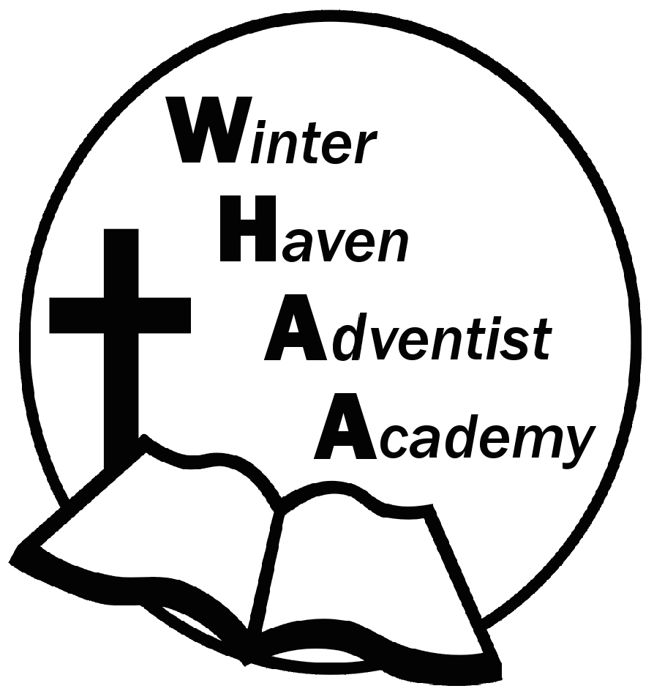
Winter Haven Adventist Academy
Adventist Education

A Journey to Excellence
Week 21 January 22-26, 2024 Newsletter

Dear WHAA Families,
This twenty-first week of the 2023-2024 school has been the first full school week in January since Winter Break. Worships this week were brought to us by Mrs. Turner and focused on the theme of God crafting each person for His purpose in their life.
Below are some important events to remember.
WEDNESDAY, JANUARY 31 “MUSEUM OF ART” SCHOOL FIELD TRIP: WHAA will be having a field trip on Wednesday, January 31. Students need a packed lunch that does not require the microwave for the trip. The students should wear the lime green school shirt with the logo and jeans. The cost will be $20 per student. Students K-5 will be doing a Dig and Discover tour. Students in grades 6 and up will be doing the Art of Ancient Americas tour. The bus will leave school by 8:15 a.m. and arrive back at school around 3:30 p.m.
SATURDAY, MARCH 2 SCHOOL PROGRAM AND FAMILLY PICNIC: WHAA will be having another church program at Avenue K on Saturday, March 2. The date was changed due to a speaker coming on February 24. Instead of the usual fellowship dinner at the school after the program for a picnic we are inviting all the families to take their food contributions to Circle Bar B Reserve Park. All families are invited to bring simple foods for this fellowship picnic event. Consider foods that can be served at room temperature with no microwaves. Families may want to bring a change of clothes and chairs for sitting. Feel free to invite others, the park has plenty of paths for walking and the weather hopefully will be beautiful.
Thank you for your prayers and support. WHAA continues to pray for all the families. Have a blessed and restful weekend!

- Important Dates:
Wednesday, January 31, “Museum of Art” Orlando $20 per child and adult
Wednesday, March 6 Skateworld STEM on WHEELS_Tampa $20 per child and adult
Monday-Friday, March 11-15 Spring Break (No School)
Wednesday April 10, Cracker Country, Pioneer Village_Tampa Fair Grounds, $20 per child and adult
Wednesday May 22, CocoKeys Water Resort_Orlando, $20 per child and adult

Winter Haven Adventist Academy (WHAA)
"Wisdom and Harmony, Anchored in Achievement"

The Wisdom of God, the Harmony of the Holy Spirit, Anchored
in Jesus and Advancing the Achievement Together.

