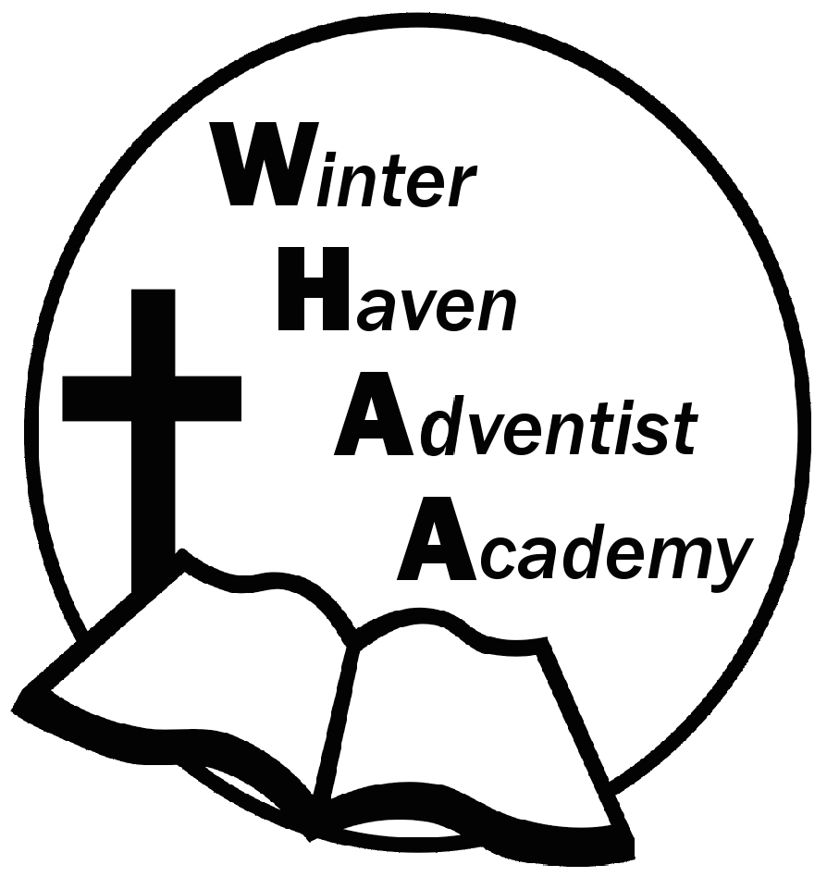
Winter Haven Adventist Academy
Adventist Education

A Journey to Excellence
Week 22 January 29-February 2, 2024 Newsletter

Dear WHAA Families,
This twenty-second week of the 2023-2024 went well and the Orlando Museum of Art was a wonderful experience. Many positive compliments were given to the students. Worships this week were brought to us by Mr. Jervis and focused on the theme of serving God.
Below are some important events to remember.
MONDAY-THURSDAY, FEBRUARY 5-8 WRITING TEST: WHAA will be administering the National Writing assessment during this week. Please make sure students get plenty of rest for this upcoming writing exam.
FRIDAY, FEBRUARY 9 MID TERM GRADES FOR QUARTER 3: Midterm reports (Grades 1-8) for the third quarter will be handed out during dismissal on Friday, February 9. Remember these are not final grades and can be improved upon before the third quarter comes to an end.
SATURDAY, MARCH 2 SCHOOL PROGRAM AND FAMILLY PICNIC: WHAA will be having another church program at Avenue K on Saturday, March 2. Instead of the usual fellowship dinner at the school everyone is invited to join the school for a fellowship picnic at Circle Bar B Reserve Park. The school will provide vegetarian hotdogs and families are invited to bring simple foods for this fellowship picnic event. Consider foods that can be served at room temperature with no microwaves. Families may want to bring a change of clothes and chairs for sitting. Feel free to invite others, the park has plenty of paths for walking and the weather hopefully will be beautiful.
Thank you for your prayers and support. WHAA continues to pray for all the families. Have a blessed and restful weekend!

- Important Dates:
Monday-Thursday, February 5-8 Writing Assessment (Grades 3-8)
Wednesday, March 6 Skateworld STEM on WHEELS_Tampa $20 per child and adult
Monday-Friday, March 11-15 Spring Break (No School)
Wednesday April 10, Cracker Country, Pioneer Village_Tampa Fair Grounds, $20 per child and adult
Wednesday May 22, CocoKeys Water Resort_Orlando, $20 per child and adult

Winter Haven Adventist Academy (WHAA)
"Wisdom and Harmony, Anchored in Achievement"

The Wisdom of God, the Harmony of the Holy Spirit, Anchored
in Jesus and Advancing the Achievement Together.

