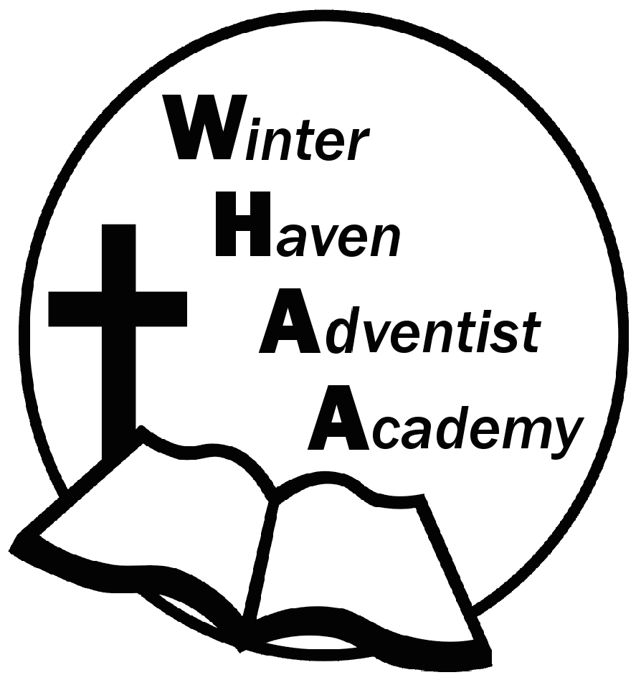
Winter Haven Adventist Academy
Adventist Education

A Journey to Excellence
Week 4 September 4-8, 2023 Newsletter

Dear WHAA Families,
This fourth week of the 2023-2024 school year has flown by. WHAA would like to introduce Tiffany Quest who has joined the school team. We have a wonderful group of students thanks to our supportive WHAA families.
Below are some important events to remember.
FIELD TRIP: WHAA plans to go to MOSI (Museum of Science and Industry) on October 4 (Wednesday). More information will be coming soon.
MAPS TESTING: This was a successful week of getting the majority of the testing completed. We appreciate all of the families and their support during this testing period.
SATURDAY, SEPTEMBER 30 FAMILY SABBATH: WHAA has a full day planned for the families and students on Saturday, September 30. WHAA will be having a church program, followed by a fellowship dinner in the school gymnasium, then the school plans to have a family outing in the afternoon. The family day will continue with an evening vesper at the church, followed by a PIE (Parents Involved in Education) meeting in the school gymnasium. This PIE meeting will involve fun activities for all ages. We look forward to a great day together.
Thank you for your prayers and support. WHAA continues to pray for all the families. Have a blessed and restful weekend!

- Important Dates:
Saturday, September 30 Family Sabbath (Students have program, fellowship dinner, family outing, vespers, followed by Pie Meeting)
Field Trip, October 4, MOSI - Tampa

Winter Haven Adventist Academy (WHAA)
"Wisdom and Harmony, Anchored in Achievement"

The Wisdom of God, the Harmony of the Holy Spirit, Anchored
in Jesus and Advancing the Achievement Together.

