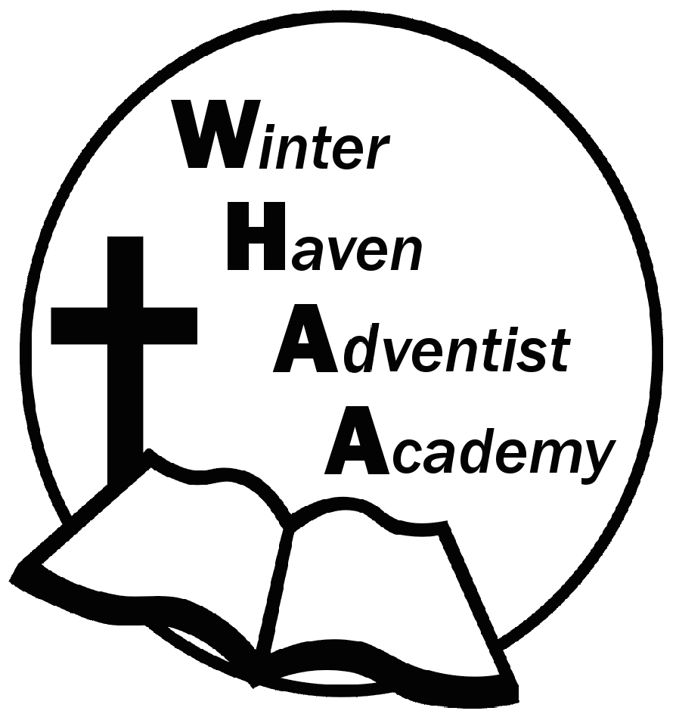
Winter Haven Adventist Academy
Adventist Education

A Journey to Excellence
Week 5 September 11-15, 2023 Newsletter

Dear WHAA Families,
This fifth week of the 2023-2024 school year has been amazing. Worships this week were brought to us by Mrs. Shepherd and her class presented on Friday. They were WONDERFUL! This year we began the year with morning worships together as a school and it has been a fantastic adjustment to our schedule. We encourage the parents to continue to bring their children on time to enjoy fellowship with Jesus from 8:00-8:20 each day. As always, we praise God our WHAA families and their support of Adventist Christian Education.
We have been working diligently to get our fieldtrips planned for the year so that parents can make adjustments to their schedules. If they would like to accompany us. Because most places require payment a month in advance, it is important that we know how many students and adults to plan for with each event. Mr. Grimm will be sending out a document for you to respond to NEXT WEEK in regard to the dates listed below.
Below are the field trips and special program dates for the 2023-2024 school year:
FIELD TRIPS:
(Wednesday) October 4, MOSI_Museum of Science and Industry_ Tampa, $20 per child and adult
(Wednesday) November 15, SeaWorld_Orlando, $40 per child and adult
(Wednesday) December 13, Ice Factory_ Kissimmee, $20 per child and adult (who is ice skating)
(Wednesday) January 31, Museum of Art_Orlando, $20 per child and adult
(Wednesday) March 6 Skateworld STEM on WHEELS_Tampa, $20 per child and adult
(Wednesday) April 10, Cracker Country, Pioneer Village_Tampa Fair Grounds, $20 pere child and adult
(Wednesday) May 22, CocoKeys Water Resort_Orlando, $20
SATURDAY, SEPTEMBER 30 FAMILY SABBATH: WHAA has a full day planned for the families and students on Saturday, September 30. WHAA will be having a church program, followed by a fellowship dinner in the school gymnasium, then the school plans to have a family outing in the afternoon. The family day will continue with an evening vesper at the church, followed by a PIE Meeting.
Thank you for your prayers and support.

Winter Haven Adventist Academy (WHAA)
"Wisdom and Harmony, Anchored in Achievement"

The Wisdom of God, the Harmony of the Holy Spirit, Anchored
in Jesus and Advancing the Achievement Together.

