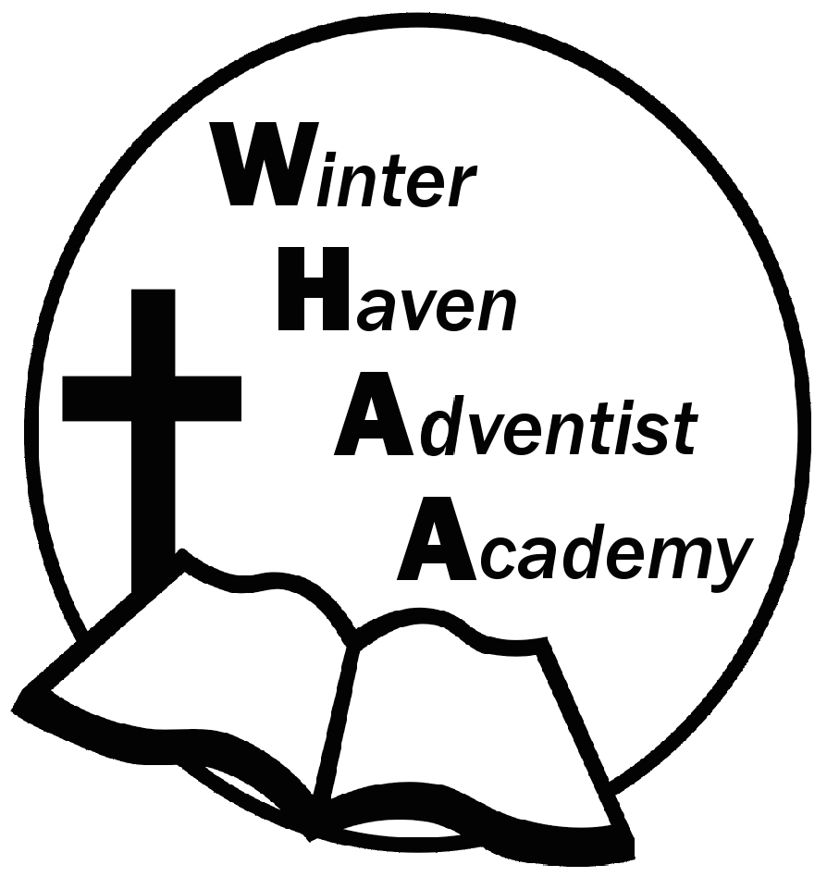
Winter Haven Adventist Academy
Adventist Education

A Journey to Excellence
Week 8 October 2-6, 2023 Newsletter

Dear WHAA Families,
This eighth week of the 2023-2024 school year has been exciting, especially with the wonderful time we had at MOSI in Tampa. Only one week left until the first quarter comes to an end. Worships this week were brought to us by Mrs. Dorsett and focused on the topic of obedience. Thank you to the parents who were able to attend the field trip. We hope you enjoyed your day. Families are always welcome.
Below are some important events to remember.
PARENT TEACHER CONFERENCES: WHAA wants to remind parents that October 23-27 will be the week of parent teacher conferences. Report cards will be given out and MAP Testing results discussed. Mr. Grimm will be providing a link next week for parents to sign up for the time preferred.
SATURDAY, NOVEMBER 11 FAMILY SABBATH: WHAA wants to remind families that the next school program will be Saturday (Sabbath), November 11. More details to come.
Thank you for your prayers and support. WHAA continues to pray for all the families. Have a blessed and restful long weekend!

- Important Dates:
Monday, October 9 Columbus Day (No School)
Saturday, November 11 Family Sabbath
Wednesday, November 15 Sea World Orlando $40 per child and adult
Monday-Friday, November 20-24 Fall Break (No School)
Wednesday, December 13 Ice Factory Kissimmee $20 per child and adult (who is ice skating)
Monday-Friday, December 18-January 1 Winter Break (No School)
Tuesday, January 2 Classes Resume for Third Quarter

Winter Haven Adventist Academy (WHAA)
"Wisdom and Harmony, Anchored in Achievement"

The Wisdom of God, the Harmony of the Holy Spirit, Anchored
in Jesus and Advancing the Achievement Together.

