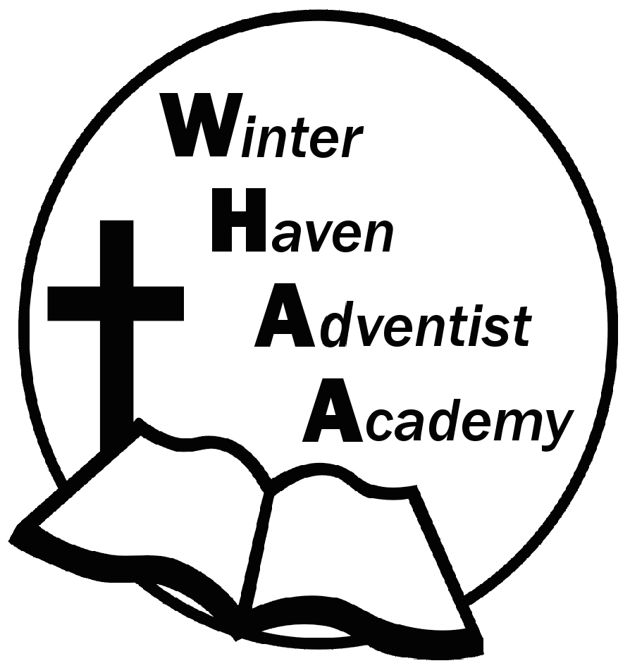
Winter Haven Adventist Academy
Adventist Education

A Journey to Excellence
Week 9 October 9-13, 2023 Newsletter

Dear WHAA Families,
This ninth week of the 2023-2024 school year has been another interesting week. Our first quarter has come to an end. Worships this week were brought to us by Mr. Jervis and focused on the topic of courage. Thank you for everyone’s support in Adventist Education
Below are some important events to remember.
PARENT TEACHER CONFERENCES: WHAA wants to remind parents that October 23-27 will be the week of parent teacher conferences. Report cards will be given out and MAP Testing results discussed. Mr. Grimm has provided a link below for parents to sign up for the time preferred. High school parents will click under Mrs. Turner’s name to setup appointment.
Link: https://forms.gle/N65MyKzVLXnMAhSZ9
SATURDAY, NOVEMBER 11 FAMILY SABBATH: WHAA wants to remind families that the next school program will be Saturday (Sabbath), November 11. WHAA plans to have the church service, potluck, and an evening vesper.
Thank you for your prayers and support. WHAA continues to pray for all the families. Have a blessed and restful weekend!

- Important Dates:
Saturday, November 11 Family Sabbath
Wednesday, November 15 Sea World Orlando $40 per child and adult
Monday-Friday, November 20-24 Fall Break (No School)
Wednesday, December 13 Ice Factory Kissimmee $20 per child and adult (who is ice skating)
Monday-Friday, December 18-January 1 Winter Break (No School)
Tuesday, January 2 Classes Resume for Third Quarter

Winter Haven Adventist Academy (WHAA)
"Wisdom and Harmony, Anchored in Achievement"

The Wisdom of God, the Harmony of the Holy Spirit, Anchored
in Jesus and Advancing the Achievement Together.

