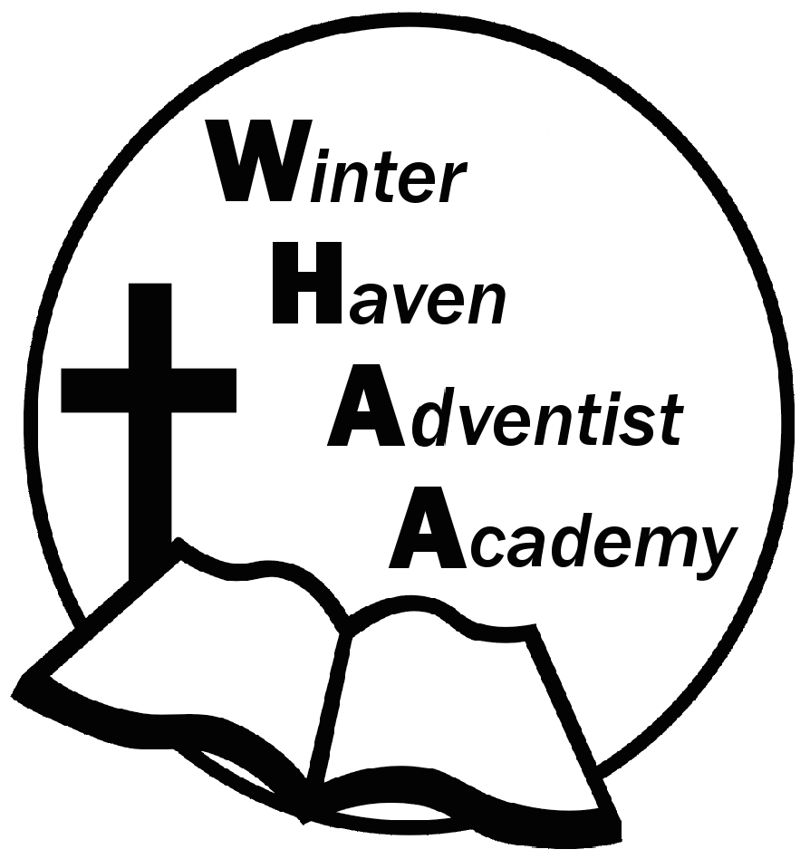
Winter Haven Adventist Academy
Adventist Education

A Journey to Excellence
Week 23 February 5-9, 2024 Newsletter

Dear WHAA Families,
We are doing our best to communicate to parents with these newsletters, please take the time to read them. This twenty third week of school grades 3-8 were busy taking the National Writing Assessment Program (WrAP). Worships this week were brought to us by Mr. Grimm and focused on the theme of self-control.
Below are some important events to remember.
FRIDAY, FEBRUARY 16 PROFESSIONAL DEVELOPMENT NO SCHOOL: School will be closed on Friday, February 16, due to teacher in-service.
MONDAY, FEBRUARY 19 PRESIDENTS DAY NO SCHOOL: Due to the holiday of Presidents Day school will be closed on Monday, February 19.
SATURDAY, MARCH 2 SCHOOL PROGRAM AND FAMILY PICNIC: WHAA will be having our third church program at Avenue K on Saturday, March 2. Instead of the usual fellowship dinner at the school everyone is invited to join the school for a fellowship picnic at Circle Bar B Reserve Park. The school will provide vegetarian hotdogs and families are invited to bring simple foods for this fellowship picnic event. Consider foods that can be served at room temperature with no microwaves (chips, salads, sandwiches, etc). Families may want to bring a change of clothes and chairs for sitting. Feel free to invite others, the park has plenty of paths for walking and the weather hopefully will be beautiful.
Thank you for your prayers and support. WHAA continues to pray for all the families. Have a blessed and restful weekend!

- Important Dates:
Friday, February 16 Professional Development (No School)
Monday, February 19 Presidents Day (No School)
Wednesday, March 6 Skateworld STEM on WHEELS_Tampa $20 per child and adult
Monday-Friday, March 11-15 Spring Break (No School)
Wednesday April 10, Cracker Country, Pioneer Village_Tampa Fair Grounds, $20 per child and adult
Wednesday May 22, CocoKeys Water Resort_Orlando, $20 per child and adult

Winter Haven Adventist Academy (WHAA)
"Wisdom and Harmony, Anchored in Achievement"

The Wisdom of God, the Harmony of the Holy Spirit, Anchored
in Jesus and Advancing the Achievement Together.

